PROVISIONAL MARKING KEY
PHYSICS II

QUESTION 1
- Tie a metal block to a spring balance using the thin thread/(1). Note the spring balance reading before releasing the metal block to hang/(1).
- Release the block and allow it to settle in the air. Note its reading/(1).
- Fill some water into the beaker/(1).
- Note the level of the water/(1).
- Lower the metal block gently into the water/(1).
- Note the spring balance reading when it is partially immersed/(1) and when it is wholly immersed in water/(1).
- Calculate the upthrust of the liquid using the readings in air/(1) and wholly immersed in water/(1).

QUESTION 2
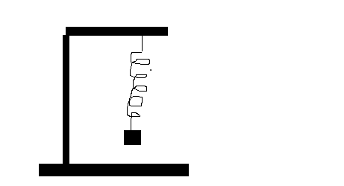
3 marks for correctly labelled diagram:
1 for spiral spring
1 for retort stand
1 for correct diagram
a. Set up the apparatus as shown above.
b. Hang a mass e.g 50g on the lower end of spring. /(1)
c. Pull the mass downwards and allow it to oscillate. /(1)
d. Take time for 10 oscillations using stop watch /(1), and record it in
table of results/(1),.
e. Calculate frequency and record in the table of results /(1),.
f. Repeat /(1), steps (b) to (e) using different masses e.g 100g, 150g and 200g.
g. Compare the masses and their frequencies /(1),.

QUESTION 3

Current (A) | Voltage (V)
0.2 | 1 (0.9- 1.1)
0.3 | 1.5 (1.4- 1.6)
0.4 | 2 (1.9- 2.1)
0.6 | 3 (2.9- 3.1)
Acceptable range = ±0.1V
Each correct value of voltage = 1 mark

e.
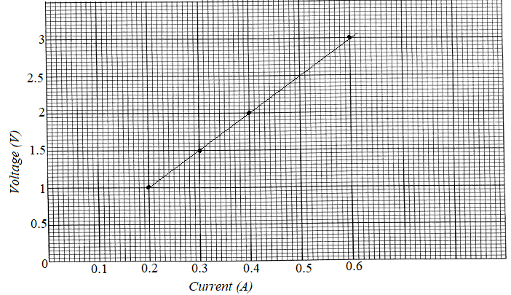
Correct scale on both axes = (1)

Correct labelling on both axes = (1)
Correct plots = 2 marks (1 mark for one pair of correct plots)

Correct shape of graph line = (1)

f. electrical resistance /1 mark

QUESTION 4
Mass (g) | 100 | 200 | 300 | 400
Reaction force, R(N) | 0.1 | 2.0 | 3.0 | 4.0
Spring reading force, F(N) | 0.2 | 0.4 | 0.6 | 0.8
(1 mark for each entry totalling to 8 marks)

- Applied force varies directly with the reaction force /(1). As the applied force increases, the reaction force also increases /(1).

END OF PROVISIONAL MARKING KEY
(THIS KEY CAN BE ENRICHED)

